**Vehicle Models**

Tuning a controller can be much better when we have a good mathematical model of the thing we are trying to control.

The models we will talk about are how we can represent the movement of a vehicle. Of course the more realistic the model is, the more complex it will be. That is the tradeoff we will need to make.

**Kinematic Models:**

Ignore many things like gravity and tire forces and mass, but are relatively simple to use and work well.

A simplification of dynamic models. The simplification reduces the accuracy of the models, but it makes them more tractable. At low and moderate speeds, kinematic models often approximate the actual vehicle dynamics.

**Dynamic Models:**

Capture more realistic forces and accelerations.

Aim to embody the actual vehicle dynamics as closely as possible.

Might encompass tire forces, longitudinal and lateral forces, inertia, gravity, air resistance, drag, mass, and the geometry of the vehicle.

Some Dynamic models consider more of these factors than others.

Advanced dynamic models even take internal vehicle forces into account, for example, how responsive the chassis suspension is.

**State of a Vehicle**

What things do we need to know in order to keep track of a vehicle in motion? The necessary information required to know its current state, as well as predict a future state are the x and y co-ordinates, the heading angle with respect to the x axis, and the velocity in the direction of the heading.

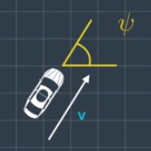

A car has 3 actuators: The steering wheel (a steering angle), a brake pad, and the throttle. We can simply this in our model to 2 control inputs of the steering angle, and the throttle and brake pad as 1 control input where negative values denote the use of the brake.

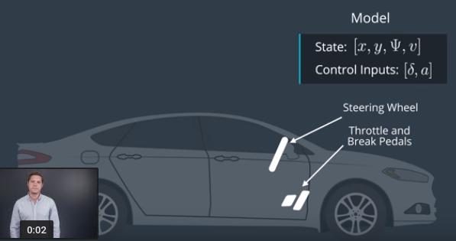

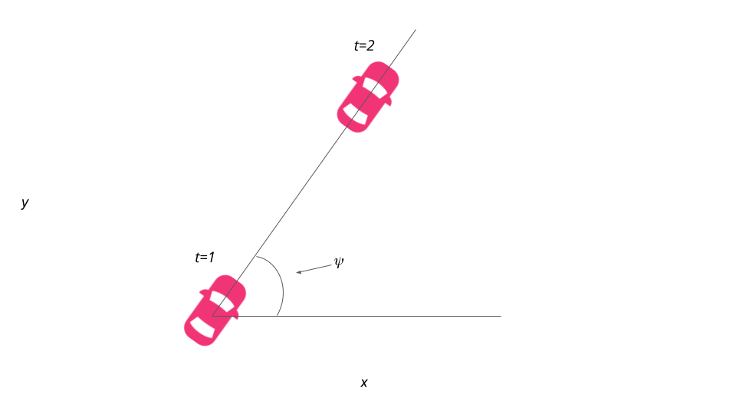

X = x + v * cos(psi) * dt

Y = y + v * sin(psi) * dt

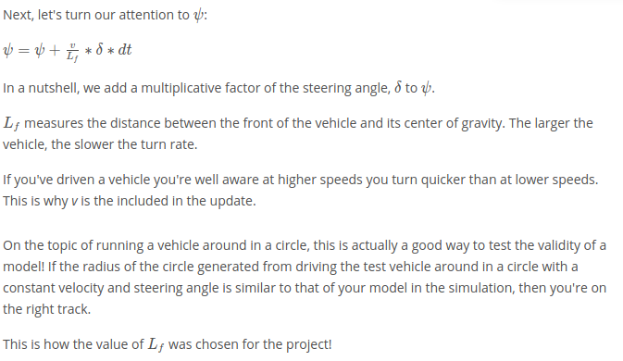

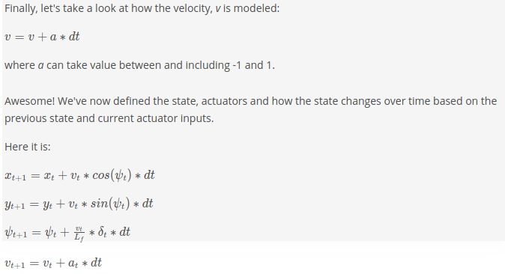

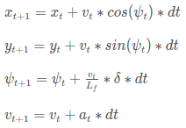

**Following Trajectories**

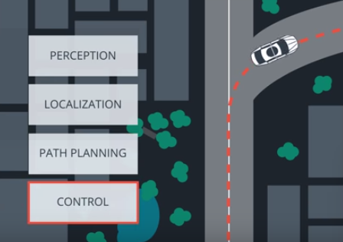

Autonomous vehicle architecture starts with the **Perception**, which estimates the state of the environment including landmarks, pedestrians, and other vehicles. Next, the **Localization** block compares the environment estimated to a map to figure out where the vehicle is. The **Path Planning** block then charts a trajectory using the environmental model, the map, and the vehicles location. Lastly, the **Control loop** then applies the actuators to follow the trajectory. The trajectory is typically a 3rd order polynomial, which is what is passed from the path planning block to the control block.

**Errors**

The controller actuates a vehicle to follow the reference trajectory within a set of design requirements. An important requirement is to minimize the error between the reference trajectory and the vehicles actual trajectory. We can do this by predicting the vehicles actual path, and then adjusting the control inputs to minimize the difference between that prediction and the reference trajectory.

This is how we can use a Kinematic Model to predict a vehicles future state.

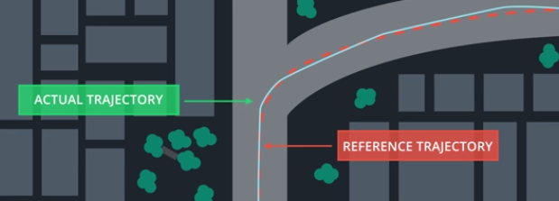

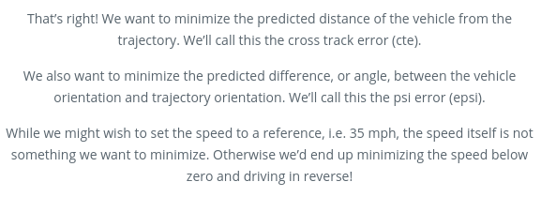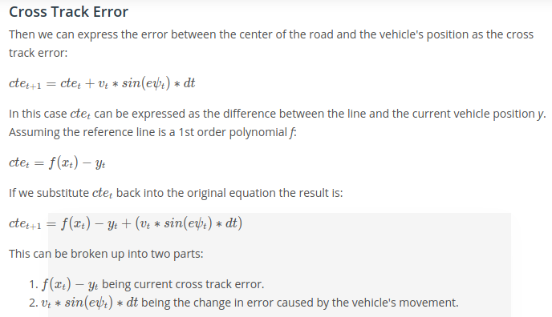

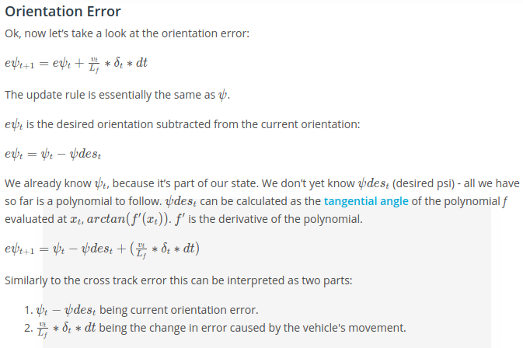

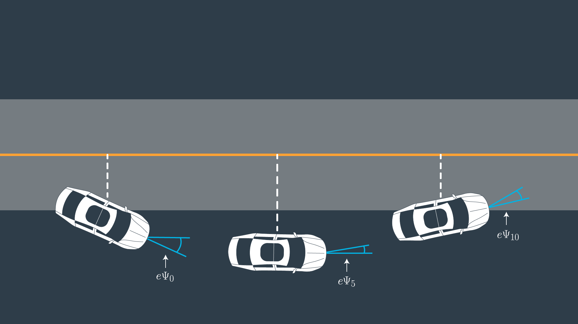

**Dynamic Model: Forces**

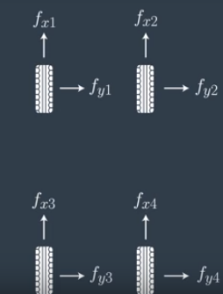Forces are broken up into Longitudinal Forces and Later Forces. The interaction between the tires and the road determine the motion of the vehicle.

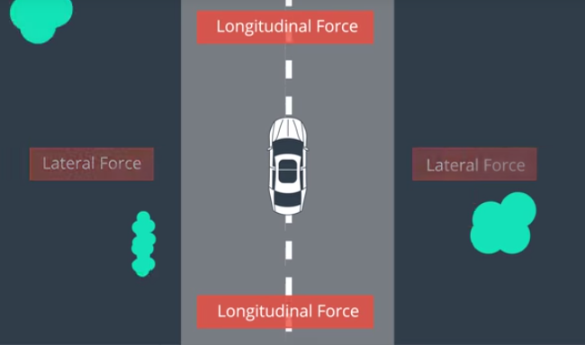

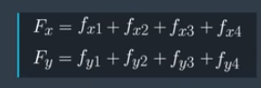

**Slip Angle:**

The angle between the velocity vector of the wheel, and the wheel orientation. The force angle generated by the slip angle is actually how a vehicle turns, because otherwise inertia would carry the vehicle off the road. Different tires have different characteristics, for example, racing tires generate much higher force from the slip angle than conventional tires.

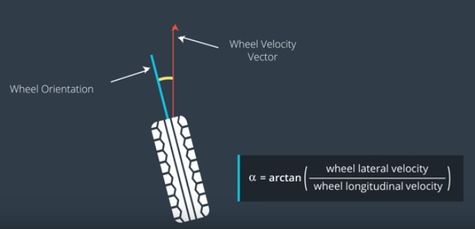

Slip Ratio:

The slip ratio is when there is a mismatch between the angular velocity of the wheel, and the expected longitudinal velocity. That mismatch means that in addition to the tires natural rolling motion, there is also a slipping motion.

Similar to how the slip angle is required to generate lateral force, the Slip ratio is required to generate longitudinal force. The force is generated when the contact patch of the tire meets the road.

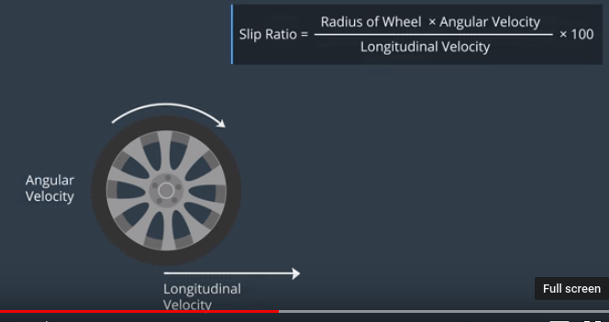

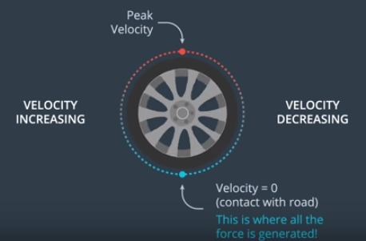

**Tire Models:**

Tire models aim to represent a tire as closely as possible.

Example: The lateral force of a tire is similar to the graph below, where alpha is the slip angle, and F is the lateral force.

Race car drivers have a good mental grasp of the optimal slip angle required to generate the most amount of force.

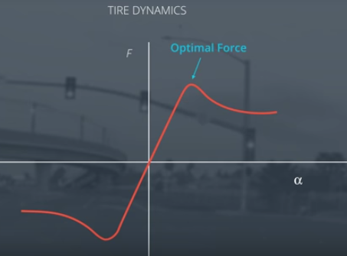

The most popular Tire Model is called the **Pacejka Tire Model**, also known as the Magic Tire Formula.

**Actuator constraints**

In a real vehicle, the actuators are limited by the design of the vehicle and fundamental physics.

An example of this is that a vehicle cant have a steering angle of 90 degrees. No car can make a perfect right angle turn. This means that we shouldn’t even consider these types of inputs to the actuator.

The term describing this type of constraint being applied to a model is **Non-Holomonic**. This means the vehicle cant move in arbitrary directions, it is limited by the steering angle constraints.

We can constrain the steering angle and the acceleration values to be within some range before they are applied to the actuator. The upper and lower bounds should mimic the actual vehicle as closely as possible.

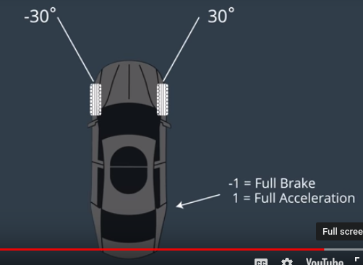

With the use of either the Dynamic model, or the Kinematic model and Actuator constraints, we can predict the motion of the vehicle given actuator inputs. With this we can predict where the vehicle will be in future time-steps, and minimize the error between the predicted trajectory and the reference trajectory. The cost function we define will be what we consider the factors required so that when we minimize it, we minimize the error between the two trajectories.